

**Green University of Bangladesh**

**Department of Computer Science and Engineering(CSE)**

**Faculty of Sciences and Engineering**

**Semester: (Spring, Year:2024), B.Sc. in CSE (Day)**

**LAB ASSIGNMENT NO #01**

**Course Title: Data Communication Lab**

**Course Code: CSE 308 Section: 221_D3**

**Experiment Name: Implementing Byte Stuffing and De-stuffing**

**Student Details**

|  |  |  |
| --- | --- | --- |
| **Name** | | **ID** |
| **1.** | Jahidul Islam | 221002504 |

**Lab Date : 02 – 03 – 2024**

**Submission Date : 16 – 03 – 2024**

**Course Teacher’s Name : Sakhaouth Hossan**

**[For Teachers use only: Don’t Write Anything inside this box]**

|  |
| --- |
| **Lab Report Status**  **Marks: ………………………………… Signature:.....................**  **Comments:.............................................. Date:..............................** |

**1. TITLE OF THE LAB EXPERIMENT:**

**Implementing Byte (Character) Stuffing and De-stuffing**

**2. OBJECTIVES:**

After complementing this lab experiment, we will gain practical knowledge and tthe outcomes of this experiment are

* To implement the data link layer framing method Character stuffing.

**3. PROCEDURE:**

First we code to stuff byte

Then again coded to destuff that input

Lastly, combined both code to implement both in a single code.

Two function for stuff and desufff byte..

**byteStuffing()**

**byteDestuffing()**

**4. IMPLEMENTATION**

De-stuffing code:

// Bismillahir Rahmanir Rahim

// jahidulZaid

//

#include <bits/stdc++.h>

using namespace std;

#define optimize() ios_base::sync_with_stdio(0);cin.tie(0);cout.tie(0);

#define endl '\n'

#define tt long long t; cin >> t;

#define ll long long

#define pb push_back

// #ifdef LOCAL

// #include "debug.h"

// #endif

// #ifdef ONLINE_JUDGE

// #include "debug.h"

// #endif

string byteStuffing(const string& input, char flag, char escape) {

    string stuffed;

    for (char ch : input) {

        if (ch == flag || ch == escape) {

            stuffed += escape;

        }

        stuffed += ch;

    }

    return stuffed;

}

string byteDestuffing(const string& input, char escape) {

    string destuffed;

    bool prevEscape = false;

    for (char ch : input) {

        if (ch == escape && !prevEscape) {

            prevEscape = true;

        } else {

            destuffed += ch;

            prevEscape = false;

        }

    }

    return destuffed;

}

int main() {

    char flag = 'F';

    char escape = 'E';

    string input;

    getline(cin, input);

    // stuffing

    string stuffed = byteStuffing(input, flag, escape);

    cout << "Byte stuffing: " << endl;

    cout <<  stuffed << endl;

    cout << endl;

    // De-stuffing

    string destuffed = byteDestuffing(stuffed, escape);

    cout << "Byte destuffing: " << endl;

    cout << destuffed << endl;

    return 0;

}

**5. OUTPUT**

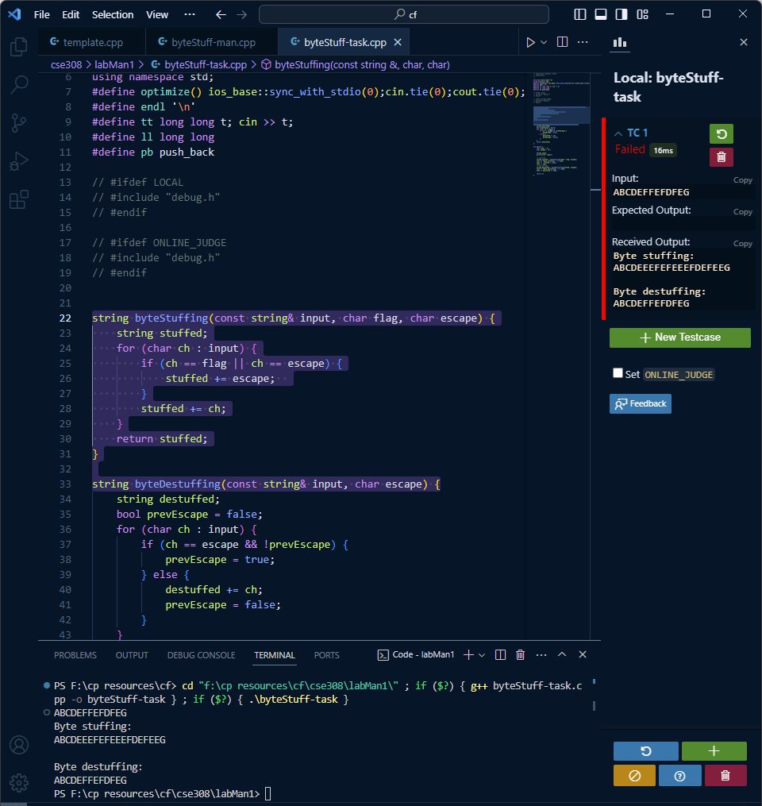

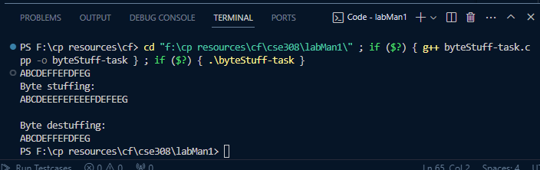

**6. ANALYSIS AND DISCUSSION:**

After following the above steps we successfully obtained the desired results.

**7. SUMMARY:**